Department | FED
Subject | DSA-2
Academic Year | I-III SEMESTER (2025-26)
Faculty Name | M D RAZIA
Student Name | VUNGARALA MOUKTHIKA
Roll Number | 2520090181
Branch | CSE
Course Outcome | CO-4

Case study Topic: BMTC Bus Route Optimization — Shortest Travel Time Analysis using Bellman-Ford Algorithm
Work Done Summary:
In this case study, the Bellman-Ford Algorithm was implemented to determine the shortest travel time from Majestic (MJC) to all other BMTC hubs during the 5 PM peak-hour window. The route network included surge-zone penalties and a negative-weight edge representing the dedicated bus lane between Whitefield (WHF) and Marathahalli (MRT), which reduces travel time by 3 minutes. Since Dijkstra's algorithm cannot correctly handle negative edge weights, Bellman-Ford was used.
Implementation Details:
- Represented the BMTC route network as a directed weighted graph with 7 hubs and 11 routes.
- Initialized the source hub (MJC) with distance 0 and all other hubs with infinity.
- Performed V−1 (6) relaxation iterations on all edges.
- Updated shortest travel times whenever a better route was found.
- Processed the negative edge WHF → MRT (-3) correctly.Result: Screenshots / Output
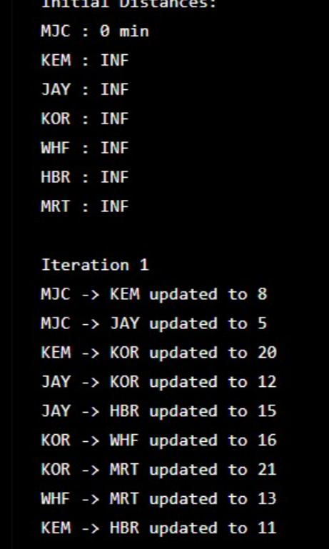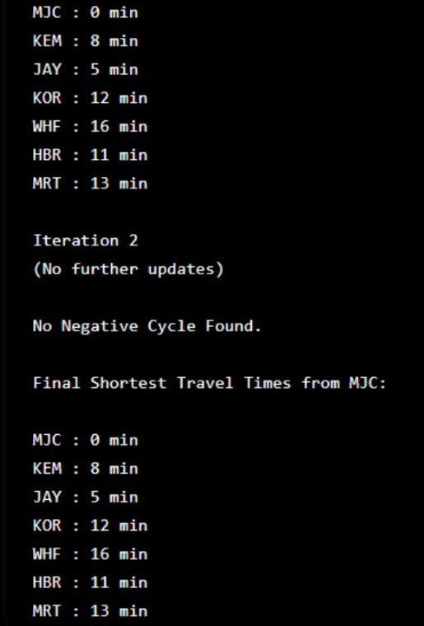

GitHub Link: moukthikavungarala/Case-Study-Project

Student Signature | Faculty Signature
__________________ | _________________

